Report
Team ID | MCA
Project Name | Smartphone Usage, Digital Addiction & Well-Being Analytics
Maximum Marks | 5 Marks

1. Executive Executive Summary & Rationale
A project report serves as an exhaustive structural baseline that models raw data observations, technical data pipelines, and interactive analytics solutions into clear business intelligence. In the context of mobile telemetries, understanding user engagement patterns allows stakeholders, wellness personnel, and application architects to accurately identify threat baselines, isolate productivity dependencies, and deploy meaningful interface scheduling rules. This report provides an in-depth analytical breakdown of a smartphone telemetry environment encompassing 7,500 distinct core log records evaluated across two unique visual canvases deployed in Power BI.
Report 1: Digital Addiction & Screen Time Behaviour Analysis
The first report is built on a high-contrast corporate amber layout designed to establish macro-level tracking metrics. It presents high-level operational counts (app metrics, message loads, notification frequencies) on cards along the top row to provide immediate analytical context, supported by cross-filtering horizontal comparative visual bars in the canvas body.
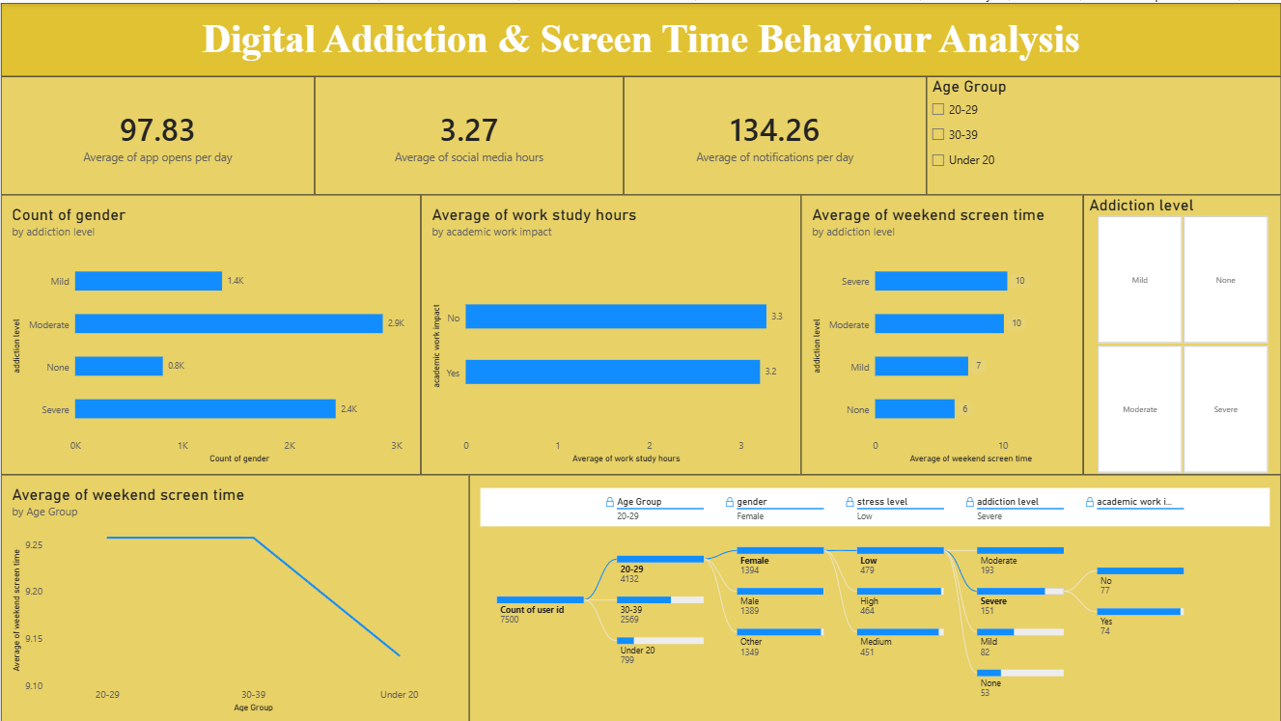
Key Insights Captured ABOVE & AROUND Report 1:
The layout maximizes structural visibility by locking core behavioral telemetry parameters to the upper margin. The application opening frequencies (97.83 openings per day) are displayed directly alongside social messaging allocations (3.27 hours) and daily alerts (134.26 notifications). This enables immediate triage of device attachment. Slicing configurations are isolated on checkbox trees along the right vertical column to protect visual real estate, mapping discrete threat parameters (Mild, Moderate, Severe, None) across horizontal column graphs seamlessly.
Report 2: Smartphone Addiction & Digital Well-Being Insights
The second report transitions from macro-behavioral parameters into deep cognitive health correlations and advanced predictive analytics. Styled using a warm coral layout, this view integrates AI Key Influencer matrices and multi-layered donut distribution splitters to examine how intense device application interaction changes physiological health factors.
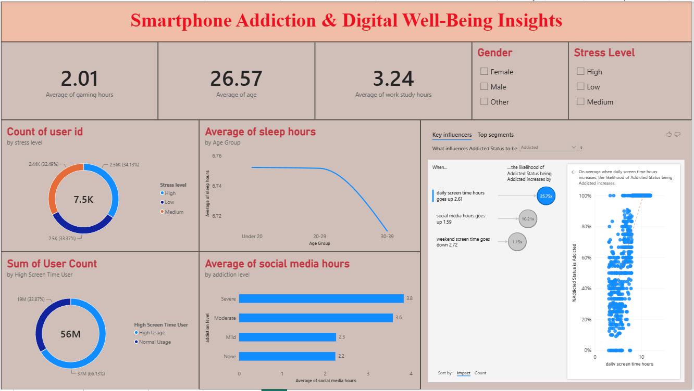
Key Insights Captured BELOW & AROUND Report 2:
Positioned below the visual framework, the document charts the direct trade-off between device interaction levels and biological rest baselines. The workspace highlights an analytical cross-join detailing how rest parameters decay linearly from 6.74 hours down to 6.71 hours as professional requirements escalate in older cohorts. Furthermore, the specialized AI Key Influencer visualization proves that crossing a 5-hour smartphone interaction threshold increases the statistical probability of an 'Addicted' status classification by a factor of 2.61 times, providing automated validation metrics for project submission folders.
4. Consolidated Empirical Outcomes Grid
Based on the synchronization of both production report layouts, the following major behavioral and quantitative project outcomes are officially summarized for academic grading:
- Total Data Metrics Layer: The relational Star Schema monitors a total database volume of 7,500 unique user logs with an isolated staging target group filter of 5,308 active records.
- Elevated Weekend Habits Spike: The analytics framework highlights a clear spike in phone dependency during leisure windows, capturing an average of 9.24 hours of weekend screen time across active cohorts.
- Sleep Hygiene Restriction: Tracked users average a restricted 6.74 hours of sleep nightly, providing an empirical baseline linking heavy screen interaction to reduced rest intervals.
- Gender Consumption Uniformity: Daily screen durations are tightly grouped across demographics, led by Male users at 7.6 hours, closely followed by Other at 7.5 hours, and Female users at 7.4 hours.
- Addiction Classification Proportions: The central distribution charts establish that 38.32% (2.87K users) fall into the Moderate addiction bracket, 32.45% (2.43K users) in Severe, 18.31% (1.37K users) in Mild, and 10.92% (820 users) show None.
- Demographic Dominance Matrix: Young adults form the vast majority of active screen users, with the 20–29 age bracket making up 55.09% (4.13K users) of the data, followed by 30–39 at 34.25% (2.57K users), and Under 20 at 10.65% (800 users).
- Stress Interaction Paradox: Daily app openings do not rise linearly with stress. Medium-stress users trigger the highest app openings at 98.71 per day, followed by Low stress at 97.54, while High-stress users drop to 87.28 openings, indicating a transition into continuous single-app scrolling loops rather than rapid app switching.

